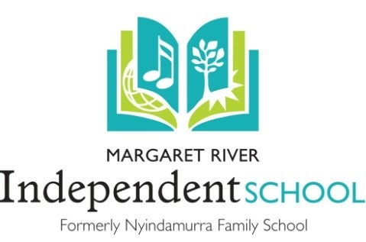

Complaints & Disputes Policy

Revision  Date | GB  Approval  Date | Changes Made | Author of  Changes
2015 |  | Created
May 2018 |  | draft changes to add to policy: definitions, principals,  anonymous complaints, record of complaints, support  person, changes to flowchart and other minor  changes, links to other documents | Galatee Underwood
November 2020 |  | Update Flowchart based on AISWA feedback; include NVC reference; update reference to other policies; include NOCS complaint handling guidelines | Galatee Underwood
Dec 20 | 7/12/20 | Issued | GB
Sep 23 | 11/09/23 | Addition of 8. Complaint Dismissal | CG & JW
Changes to this policy/document should be replicated in the following documents;
• School website
• Staff Code of Conduct
• Volunteer policy
• Parent Handbook
• Child Protection Policy
• Governing Body Manual
References and other document links
- nocs-complaint-handling-reference-guide
- Child Safe Organisation Principles
- “Parent Voice” Feedback form

Table of Contents
MRIS COMPLAINTS AND DISPUTES POLICY 3
Objective 3
Rationale 3
Principles Underlining the Policy 3
Definitions 3
Procedures 4
The complaints process at MRIS: 4
1. Who May Complain 4
2. How the complaint will be handled 4
3. Flow Chart (Att.1) 4
4. Lodging a Complaint 5
5. Withdrawal of a Complaint 5
6. Anonymous Complaints 5
7. School Support person for meetings about complaints 5
8. Complaint Dismissal 5
Att.1 Complaints and Disputes Procedures FLOW CHART 6
Att. 2 Complaint Handling Guidelines - National Organisation for Child Safety 7

MRIS COMPLAINTS AND DISPUTES POLICY

Objective
To establish a clear and unambiguous procedure for the effective management and resolution of complaints and disputes within the School community.

Rationale
To respond positively and timely to complaints and disputes that utilises the values of our Family School of respect for the individual and Social Justice.
Communication at the school is based on a co-operative and participatory philosophy where members work together to communicate effectively to resolve problems in a positive and mutually respectful way.

Principles Underlining the Policy
The following principles apply to the management of all complaints and disputes:
- The process is accessible to all parties and is underpinned by the commitment of the school for procedural fairness.
- All complaints and disputes are managed confidentially through the resolution process.
- All members are treated with respect and courtesy through the process.
- Complaints and disputes are dealt with efficiently, fairly and promptly.
- Information about the process is made available to all parents, students, staff and members of the local community.
- Complaints will be resolved with the wellbeing of students and staff as a priority.

Definitions
- a 'complaint' is an expression of dissatisfaction with an action taken, decision made or service
provided, or the failure to provide a service, take action or make a decision at a school.

- a complaint is considered to be 'resolved' when the complainant and the school agree on an
appropriate response or remedy

- a complaint is considered to be 'finalised' when the school has made a final determination on the matter after exhausting the processes set out in this policy

- a complaint is considered to be ‘dismissed’ when the school has made a final determination that the complaint is frivolous, vexatious or has little or no relevance to the school.

- a complaint is considered to be 'unresolved' when agreement cannot be reached on a course of action and/or a remedy, or if the remedy cannot be implemented.

Procedures

The complaints process at MRIS:

Who May Complain
Students, parents, members of the community and staff.

How the complaint will be handled
- Complaints or disputes will be handled promptly, confidentially and in accordance with procedural fairness.
- Persons who are the subject of a complaint or provide information in the course of an investigation into a complaint shall not be subject to prejudice, intimidation, and harassment or be subject to any detriment because of their involvement.
- The outcome of formal disciplinary processes commenced against an employee as a consequence of a complaint being received is confidential between the employee and the Principal. Complainants will not be informed of the outcome of such matters due to confidentiality requirements.
- Appropriate confidentiality is to be observed in any discussion of complaints. This means that at the school these matters must remain confidential between the employee and his/her principal and any other parties that have a legitimate interest in the process. Such parties may include support persons, professional associations and teachers.

Flow Chart (Att.1)
The flow chart attached to this policy outlines the stages that take place once a complaint is
received.
Level 1: Resolution via discussion with Staff members at the school
Level 2: Resolution via the Governing Body at the school
Level 3: Resolution via an External Body

- Communication in the school is based on a co-operative and participatory philosophy and restorative justice practices
- To work together we need to communicate effectively and resolve problems in a positive and mutually respectful way
• Each of us has the right and responsibility to:
• Communicate our feelings, ideas and concerns to those around us.
• To be listened to with understanding.
• To reciprocate by listening openly and with understanding to those around us
• To arrange an appropriate time and place to talk.
• RESPONSIBILITY lies with each school member (teacher, parent & student) to find agreement(s)
solutions(s) for each situation in a way that is respectful and mutually acceptable to all parties.
- The following flowchart (Att. 1) illustrates steps to follow in sorting out issues and ideally most problems or concerns get sorted out at the first level.
- The complaint handling overview (Att.2) provides a guideline as to how to uphold the rights of children and young people, in line with the Child Safe Organisations Principles.

Lodging a Complaint
A person may make a complaint:
- Verbally, to a Teacher or the Principal. When a verbal complaint is made, written notes relating to the complaint may be recorded by the recipient of the complaint, reviewed and initialled by both complainant and recipient at the time of the complaint, to ensure true and accurate record of the matter.
- In writing, to a Teacher, Principal, or to the Chairperson of the Governing Body. A person making a written complaint must provide his or her name, address and details of the
complaint or dispute.

Confidentiality will be applied to all complaints as outlined in 2. above.

Withdrawal of a Complaint
A person who has made a complaint may withdraw the complaint at any time. A written complaint should preferably be withdrawn in writing. A verbal complaint may be withdrawn verbally and a notation made to that effect.
The staff member who received the complaint is to give notice to any parties affected by the complaint that it has been withdrawn. Complaints that warrant investigation must be pursued even though the complaint has been withdrawn.

Anonymous Complaints
The school requires all complaints to be considered. However, it recognises that its staff and
Chairperson might not be able to fully consider a complaint if they cannot effectively liaise with the
complainant. Furthermore, anonymous complaints raise natural justice issues for respondents who
have a right to know particulars of the allegations made against them.
The school staff responsible for handling complaints should determine, in consultation with other
relevant personnel from the school and Governing Body, the extent to which an anonymous
complaint received by the school shall be investigated.

School Support person for meetings about complaints
While the matter is at the school level (level 1 or 2 on Flowchart), the complainant or the recipient of a complaint may feel the need for support or facilitation at a meeting. Whether the meeting is about making an initial complaint or attempting to resolve a complaint, the Chaplain or a Governing Body representative may be asked to facilitate such meeting. This can be arranged at the request of the complainant or of the recipient.

Complaint Dismissal
If, after reviewing the complaint, the Chairperson &/or the Governing Body determines that the complaint is frivolous, vexatious or has little or no relevance to the school, then the complainant will be notified that the complaint has been dismissed. Examples of matters that have little or no relevance to the school include but are not limited to complaints in relation to government mandates and complaints in relation to Family Court and Family Law matters.

Att.1 Complaints and Disputes Procedures FLOW CHART
** Using Non-Violent Communication & Collaborative Resolution in a confidential manner**
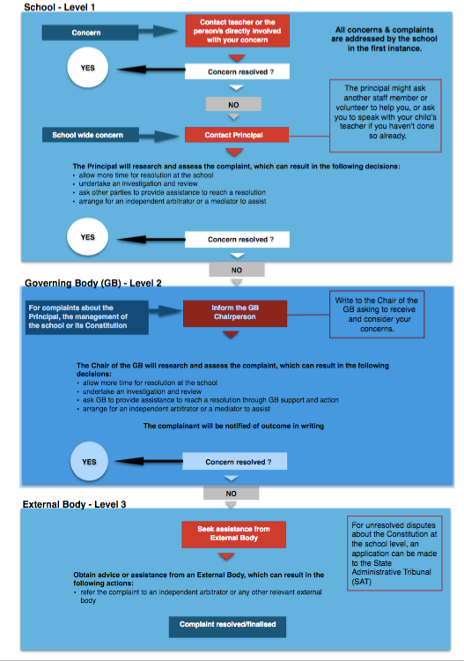

Att. 2 Complaint Handling Guidelines - National Organisation for Child Safety
